Create Xero Developer API

**1.** **Create Xero Developer API** 2

1. Log in the developer 2

2. Create apps 3

3. Creation Details 4

4. Copy client id and secret 5

5. Overview 6

# **Create Xero Developer API**

## Log in the developer

* Website: <https://developer.xero.com/announcements/all-new-api-explorer>

## Create apps

* Click “New app” bottom under “My Apps”

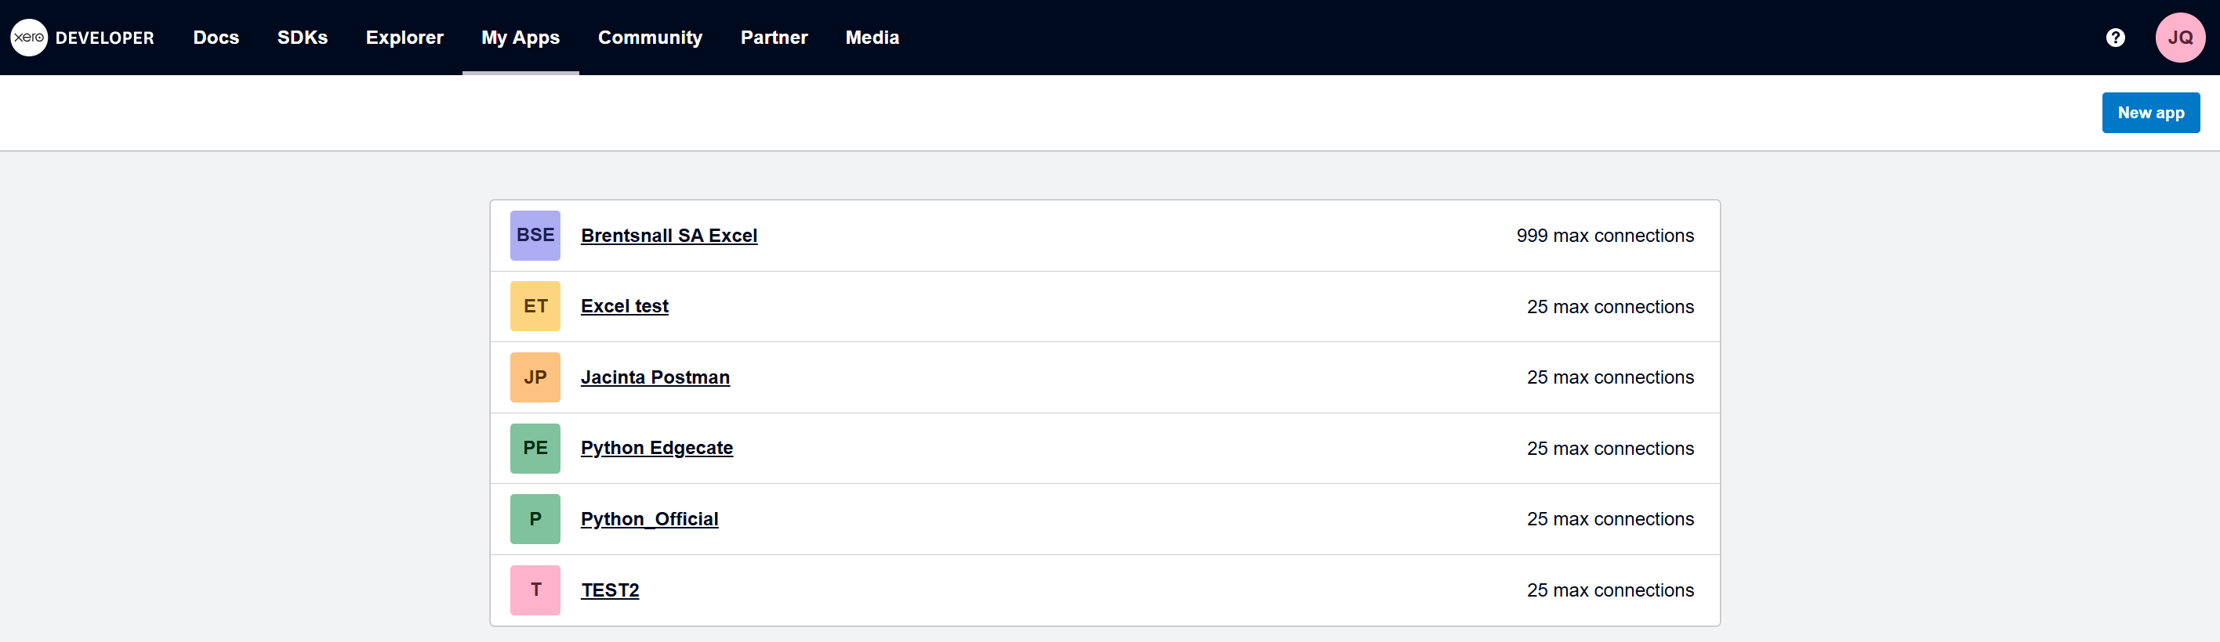

## Creation Details

* **App name:** Create by yourself, e.g.: Excel test
* **Integration type:** Web app
* **Company or application URL:** <https://www.xero.com>
* **Redirect URL:** <https://developer.xero.com/>
* **Click read**

## Copy client id and secret

* Client id: already created under configuration

* Client secret: Click Generate a secret and copy it.
* Note: Make sure to copy and paste the new secret immediately. You won’t be able to see it again.



## Overview

